TRIPLE CREEK
ENGLISH SETTERS
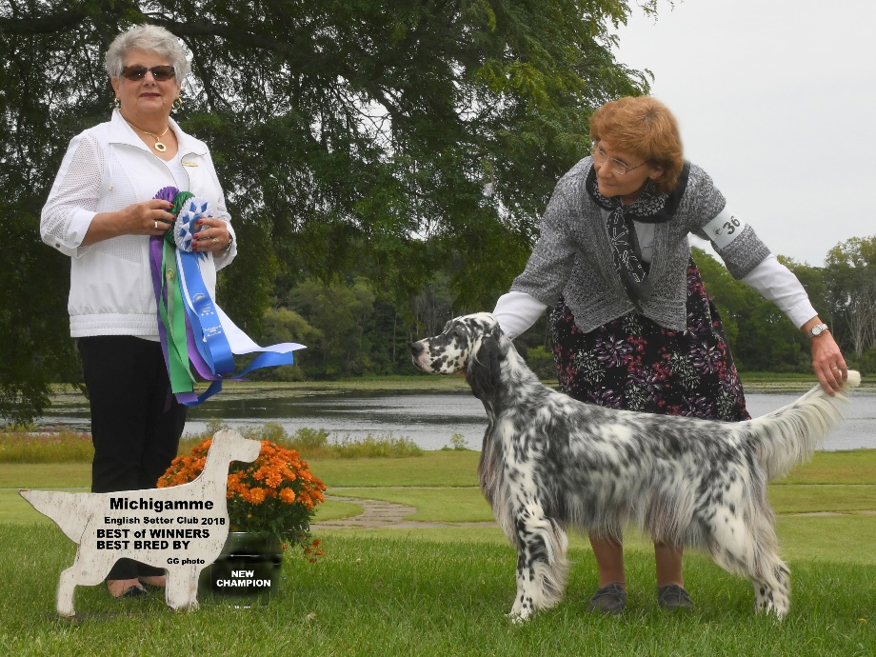

Champion Triple Creek Blue Briar

Briar Pedigree

(Owned by George & Rosemary Wheatley, Triple Creek English Setters)
Ch. Honeygait Surprise Addition
Ch. Bittersweet Nite N White Satin
Ch. Bittersweets Todays the Day
Ch. Esquire Just Jack of Triple Creek
Ch. Colthouse Millennium Man
Ch. Honeygait WilsonLake Esquire Liz
Ch. Honeygait WilsonLake Absolut
Ch. Triple Creek Blue Briar
Ch. Olde Glory Slam Dunk
Ch. Triple Creeks Fire Walker
Ch. KnobyKnols Cinda-Rella
PerryDice Pepper Spray of Triple Creek
Ch. Willowbend Ruffled Feathers
PerryDice Maranda Warnings
Ch. Aces Midnight Marauder

